Contents

Job Ad Search 1

Job Search Menu Details 1

How to Find a job in EnTireHR Application 1

# Job Ad Search

This section directs you to complete information about the job which you seek.

# Job Search Menu Details

**Job Search link will open four Tabs**

All Jobs

New Jobs

Suspended Jobs

Expired Jobs

Closed Jobs

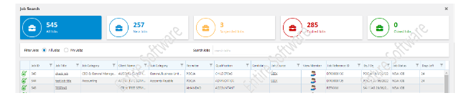

How to Find a job in EnTireHR Application:

1. Click on Placement.
2. Click on Job Ad Search
3. Four tabs will appear
   * All Jobs
   * New Jobs
   * Suspended Jobs
   * Expired Jobs

* Set the filter for if you wish to view **All jobs** **or My jobs**
* To view all the job posts available on the application cloud, Click **All Jobs**
* With this Click you will get this information.

**Job Id**

**Job Title**

**Job Category**

**Client Name**

**Sub Category**

**Recruiter**

**Qualification**

**Candidate**

**Job Source**

**View Member**

**Job Reference ID**

**By/On**

**Job Status**

**Days Left**